Retail Sales Intelligence Dashboard
Overview
This project focuses on analyzing retail sales data using Microsoft Excel to identify revenue trends, customer purchasing behavior, and product performance. The goal was to transform raw transactional data into structured insights and a clear business-focused dashboard.
Problem Statement
Retail sales data often exists in raw, unstructured formats, making it difficult for decision-makers to understand performance quickly.
The objective of this project was to:
- Clean and organize raw sales data
- Identify high-performing products and categories
- Analyze monthly and regional sales trends
- Build an interactive dashboard to support data-driven decisions
Datasets
- Raw retail transaction dataset (orders, products, regions, sales values)
- Cleaned dataset created after removing duplicates, fixing formatting issues, and standardizing fields.
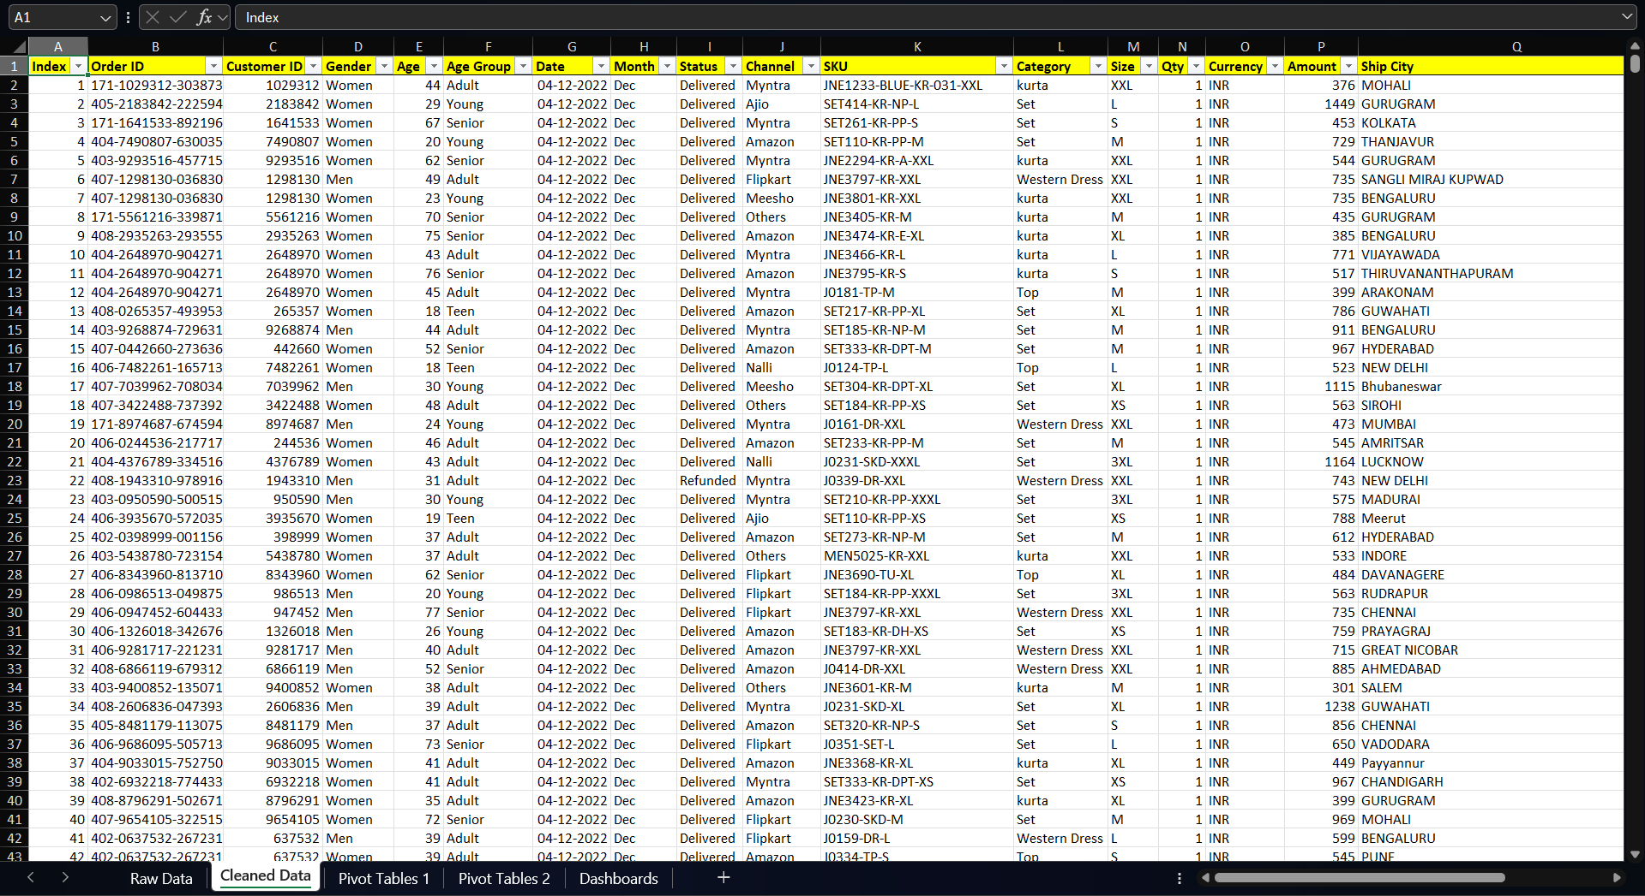
Key fields included:
- Order Date
- Product Category
- Region
- Sales Amount
- Quantity
Tools and Technologies
- Microsoft Excel
- Pivot Tables & Pivot Charts
- Data Cleaning Techniques
- IF Functions and Basic Formulas
- Sorting, Filtering, and Conditional Formatting
Methods
- Performed data cleaning by handling missing values, removing inconsistencies, and formatting columns
- Created calculated columns using Excel formulas
- Used Pivot Tables to analyze:
  - Sales by category
  - Regional performance
  - Monthly trends
- Designed a dashboard with charts and filters to make insights easy to interpret
Key Insights
- Total sales reached ₹2.11 Cr+ with over 31K units sold, indicating strong overall transaction volume.
- Adult age group contributed the highest quantity of sales, significantly outperforming Teen and Senior segments — suggesting the primary target customer base.
- Sales trend shows a gradual decline toward later months, highlighting potential seasonality or demand drop that requires investigation.
- Amazon dominated channel contribution (~35%), followed by Myntra and Flipkart, indicating strong dependency on specific marketplaces.
- Category-wise analysis shows a few product categories driving most revenue, reflecting a concentrated sales structure rather than evenly distributed performance.
- Certain states and regions consistently appear in the Top 10 sales regions, implying geographic demand clusters that can guide regional marketing strategy.
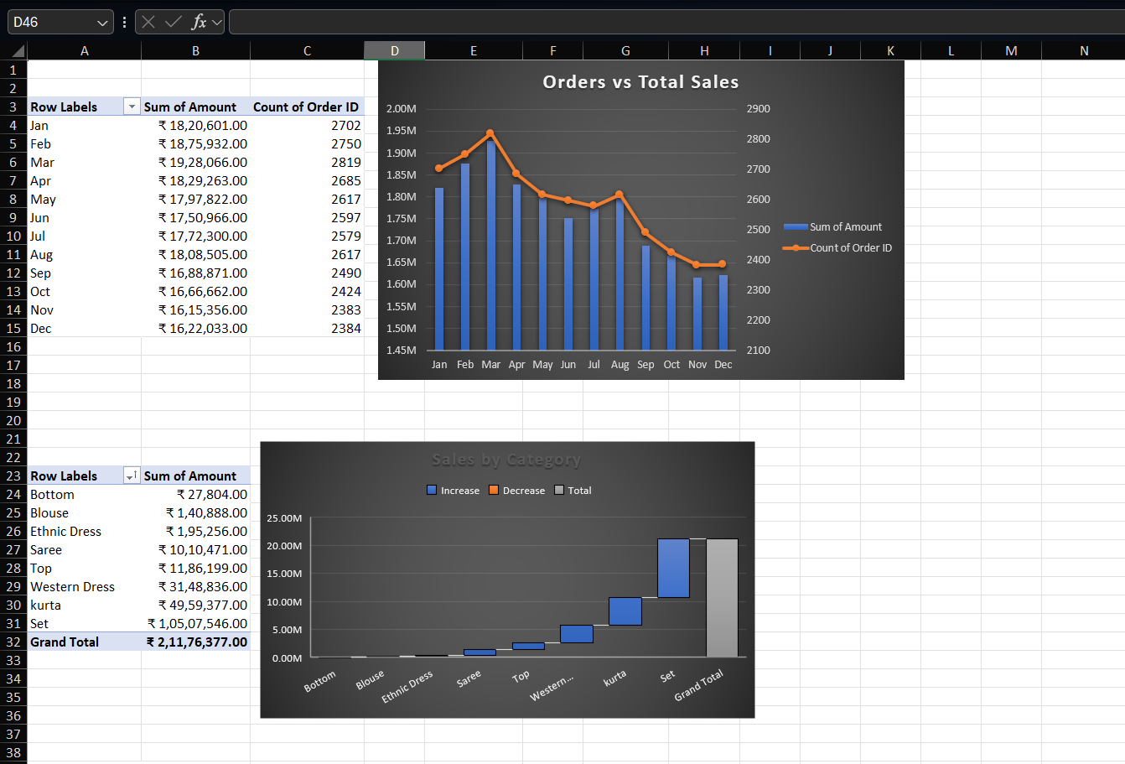
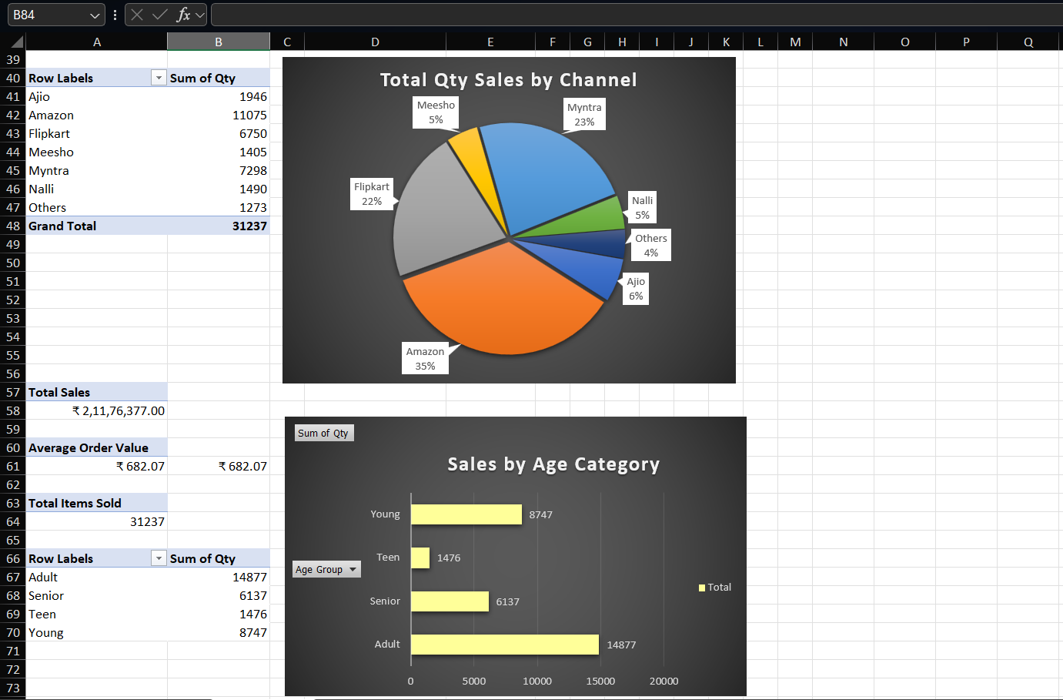
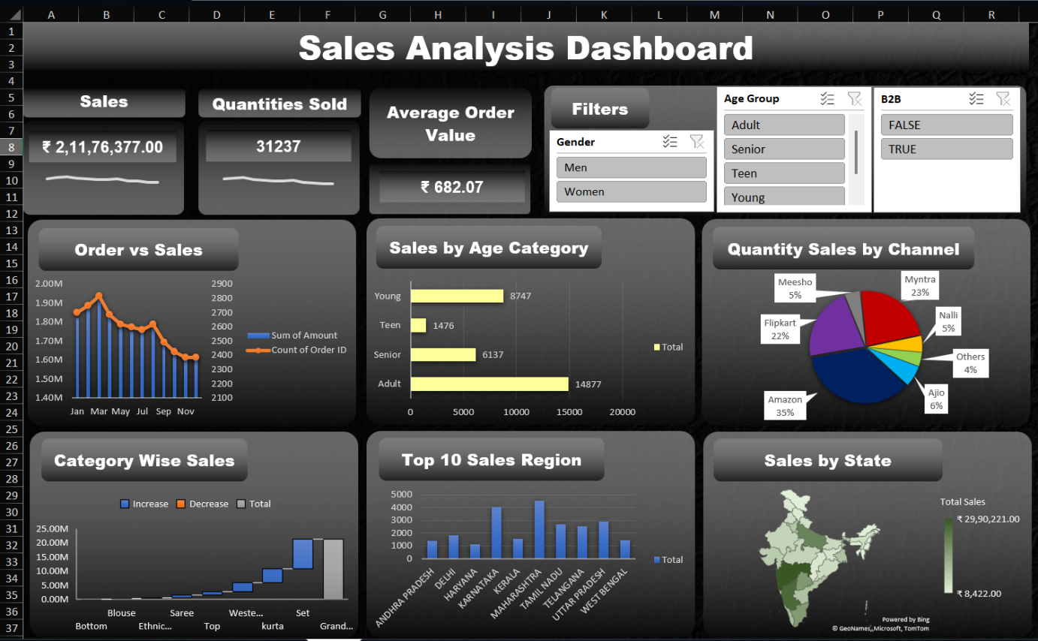
Output
- Interactive Excel dashboard displaying:
  - KPI cards for Total Sales, Quantity Sold, and Average Order Value
  - Monthly Order vs Sales trend comparison
  - Sales distribution by Age Category
  - Channel-wise quantity contribution (pie chart)
  - Category-wise sales breakdown
  - Top-performing regions visualization
  - Geographic sales distribution map across Indian states
- Dynamic slicers for Gender, Age Group, and B2B filters to enable quick segmentation and analysis.
Results & Conclusions
The analysis demonstrated how Excel can be used to convert raw retail data into actionable business insights.
By structuring the dataset and building visual dashboards, the project enables faster performance tracking and supports decisions related to product focus, regional strategy, and sales monitoring.

